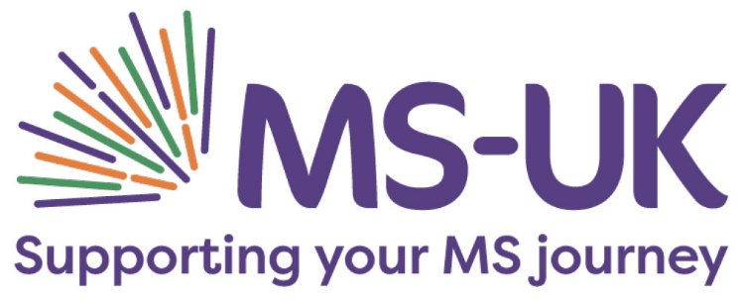

Corporate Fundraiser 1 year fixed term contract

Salary: £32,000 per annum, pro-rata

Location: Colchester

Hours: This position is a part-time role (20-25 hours per week, hybrid up to 40% of hours can be worked at home)

Are you an experienced corporate fundraiser looking for an exciting new challenge?

Following an extensive review of our corporate fundraising, we are looking to grow our corporate fundraising to enable us to reach and support more people living with multiple sclerosis (MS). If you are great at building relationships with businesses, target driven and are looking to use your talents to make a difference, we would love to hear from you!

You will be recruiting and supporting businesses of all sizes across the UK for a range of exciting corporate events as well as motivating business to maximise their support through charity of the year partnerships and their own fundraising activities.

This is a fun and varied role where you’ll be using your people skills and creative approach to maximise fundraising opportunities with new and existing supporters.

You will enjoy working in a fast-paced, high-energy environment, have excellent communication skills and have a passion for growing longstanding, successful relationships.

The role is office based with lots of pro-active telephone contact with businesses as well as representing the charity in person at networking meetings and other events.

The role is varied and provides a great opportunity for someone looking to develop their career in fundraising and is also well suited to individuals with a fundraising/sales background who thrive in a target-driven environment.

This position is a part-time role, 20-25 hours per week betwen Monday – Friday (hybrid up to 40% of hours can be worked from home after initial training, working pattern to be agreed)

The successful candidate will be required to start as soon as possible.

MS-UK is a small national charity dedicated to empowering people with multiple sclerosis (MS) to live healthier and happier lives by improving their understanding of MS and providing support where it is needed most. We put people affected by MS at the heart of our work – that’s around 130,000 people in the UK and 2.3 million worldwide. Our team are dedicated with a passion for making a difference. We pride ourselves on offering independent, unbiased information and support so people with MS can make their own choices.

We believe that our commitment to the good health and wellbeing of all our stakeholders should extend to our staff and as such we offer a generous benefits package including 25 days annual leave (pro rata), cycle to work scheme, regular team days and have a dedicated training and development budget.

We are committed to equality of opportunity for all staff and applications from individuals are encouraged regardless of age, disability, sex, gender reassignment, sexual orientation, pregnancy and maternity, race, religion or belief and marriage and civil partnerships.

To apply

Please send your CV to Sarah Wright via email to sarah@ms-uk.org with your response to the following questions (on no more than one side of an A4 document):

1. Please give an example of a successful business relationship you have developed, how you achieved this and what results were gained?

2. How do you think your skills can be applied to corporate fundraising?

3. What qualities do you have that make you right for this role?

Please do not send a cover letter or any additional information. Applications received without responses will not proceed to the next stage of our recruitment process.

Closing date: 12pm, Monday 31 July

Interviews: Tuesday 08 August – Thursday 10 August

Download the Job Description Button

