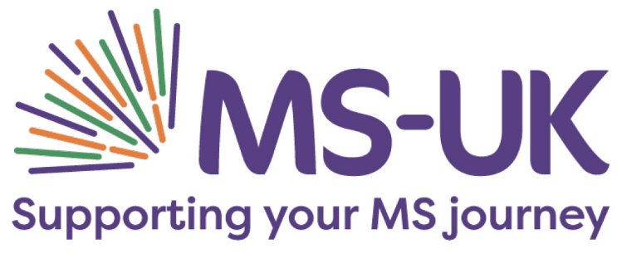

Community Fundraiser, 1 year fixed term contract

Salary: £26,000 per annum (pro-rata)

Location: Colchester

Hours: This position is a part-time role (15-20 hours per week, hybrid up to 40% of hours can be worked at home)

Do you want to make a real difference with your work? This is a fantastic opportunity to join our forward-thinking, driven fundraising team at an exciting time.

We have ambitious plans to grow community fundraising to enable us to reach and support more people living with multiple sclerosis (MS). If you are great at building relationships with people, are target driven and looking to use your talents to make a difference, we would love to hear from you!

You will be seeking, recruiting and supporting individuals and community groups across the UK to take on their own events and challenges or to take part in MS-UK’s virtual events.

This is a fun and varied role where you’ll be using your people skills and creative approach to maximise fundraising opportunities with new and existing supporters.

You will enjoy working in a fast-paced, high-energy environment, have excellent communication skills and have a passion for growing longstanding, successful relationships with new and existing supporters.

The role is primarily office based with lots of telephone contact with supporters. You will also be out and about developing support in the local community.

The role is varied and provides a great opportunity for someone looking to develop their career in fundraising. It is particularly well suited to individuals that have a fundraising/sales/customer service background and thrive in a target-driven environment.

This position is a part-time role,15-20-hours per week between Monday – Friday (hybrid up to 40% of hours can be worked from home after initial training, working pattern to be agreed)

The successful candidate will be required to start as soon as possible.

MS-UK is a small national charity dedicated to empowering people with multiple sclerosis (MS) to live healthier and happier lives by improving their understanding of MS and providing support where it is needed most. We put people affected by MS at the heart of our work – that’s around 130,000 people in the UK and 2.3 million worldwide. Our team are dedicated with a passion for making a difference. We pride ourselves on offering independent, unbiased information and support so people with MS can make their own choices.

We believe that our commitment to the good health and wellbeing of all our stakeholders should extend to our staff and as such we offer a generous benefits package including 25 days annual leave, company health insurance, life insurance and income protection and cycle to work scheme. We also hold regular team days and are committed to providing an environment that supports your wellbeing.

We are committed to equality of opportunity for all staff and applications from individuals are encouraged regardless of age, disability, sex, gender reassignment, sexual orientation, pregnancy and maternity, race, religion or belief and marriage and civil partnerships.

How To apply

Please send your CV to Sarah Wright via email to sarah@ms-uk.org with your response to the following questions (on no more than one side of an A4 document):

- What qualities do you have that make you right for this role?

- Please give an example of where you have worked to targets and how you fared?

- How would you pro-actively build and maintain relationships with people across the UK?

Please do not send a cover letter or any additional information.

Closing date: 12pm, Monday 31 July

Interviews: Tuesday 08 August – Thursday 10 August

Download the Job Description button

