**North East Essex Hyperlocal Fund 2023**

**About the fund**

The purpose of the North East Essex Hyperlocal Fund is to support non-profit groups based in local communities to build resilient local Neighbourhoods that help to improve health and wellbeing for residents.

In particular, the Hyperlocal Fund is addressing the following local priorities:

* Ways to reduce the burden of deprivation and inequalities
* Improve mental health and reduce suicide
* Tackle isolation and loneliness
* Improve physical health and the management of long-term conditions which affect local residents
* Increase physical activity to reduce obesity

Consequences of the projects may include better health and wellbeing, greater levels of confidence, stronger social relationships and take up of health services by people who face challenges to doing so.

All applications must be able to demonstrate that they will support at least one aim from this agenda. All projects must also offer a solution that reflects the Live Well campaign. The North East Essex Health and Wellbeing Alliance has adopted the campaign and its six key themes:

* 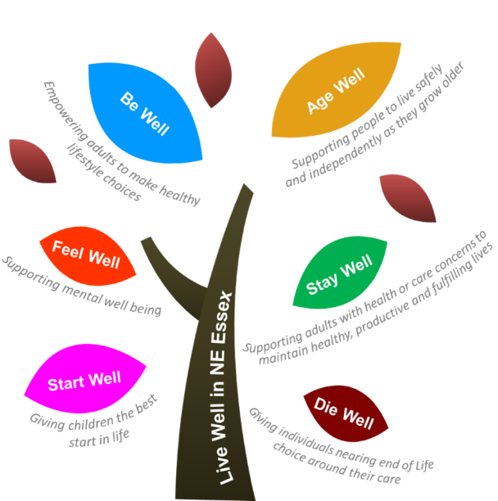**Start Well –** Giving children the best start in life
* **Feel Well** – Supporting mental wellbeing
* **Be Well** – Empowering adults to be active and make healthy lifestyle choices
* **Age Well** – Supporting people to live safely and independently as they grow older
* **Stay Well** – Supporting adults with health or care concerns to access support and maintain healthy, productive and fulfilling lives
* **Die Well** – Giving individuals nearing end of life choice around their care

Applicants can support more than one theme with their project.

We will be investing in projects that demonstrate an Asset Based Community Development (ABCD) approach. The application process is designed to capture evidence and assess how each project will be:

* **Citizen led**
* **Place-based**
* **Values Relationships**
* **Inclusive**
* **Asset-focused**

We are focused on outcomes and welcome applications from organisations able to demonstrate the effective change the funding can offer to local residents. Applicants will be asked to provide two outcomes against which their projects will be measured. Outcomes are the changes that each project is intending to make for the benefit of the people they will be working with. For further information on outcomes and shaping outcomes, please contact Community360 who will be able to provide you with support.

This fund is being administered by Community360 on behalf of One Colchester, the strategic partnership for Colchester. Funds will be distributed across the three Neighbourhood areas in Colchester. Applicants must concentrate their activities in their chosen Neighbourhood or a part of that Neighbourhood. The funding programme has been developed to distribute funds at this Hyperlocal level. The Neighbourhoods are:

**Colchester North** - includes Highwoods, Lexden and Braiswick, Rural North, Mile End, St Anne’s and St John’s

**Colchester Central** – Berechurch, Castle, New Town, Prettygate, Shrub End, Stanway

**Colchester South** – Greenstead, Marks Tey & Layer, Tiptree, Mersea and Pyefleet, Old Heath and The Hythe, and Wivenhoe

**Who Can Apply**

The grant fund invites applications from not-for-profit organisations and public sector partnerships such as:

* + Registered voluntary and charitable organisations (including Local Delivery groups of schools with charitable status)
  + Community groups
  + Tenants and residents groups
  + District, parish and town councils
  + Faith groups
  + Housing associations (not for profit only)
  + Most sports organisations (voluntary and charity only)
  + Private clubs (voluntary and charity only)
  + Most co-operatives and social enterprises (provided profits are retained for the benefit of the members or community served)
  + Mutuals
  + Community interest companies
  + Not for profit trade associations
  + Partnerships of community focussed organisations

**Decision Making**

Grants will be assessed on a regular basis and we will aim to provide applicants with a response to an application within 4 weeks.

The funding panel will include representatives from organisations who form part of the North East Essex Health and Wellbeing Alliance’s Neighbourhood teams in Colchester. They will have a local professional knowledge of the three Neighbourhoods and will have a working experience of embedding ABCD principles into their own activities.

Successful projects will contribute to, and be able to demonstrate their impact against, the outcomes they identify. All projects should be evidence based and involve local people in their delivery.

**Monitoring and evaluation**

Successful projects will be required to complete a monitoring and evaluation form (to be issued upon successful award of funds). The form must contain evidence of success achieved against the specified outcomes, lessons learnt and the legacy of the project.

A single monitoring return will be requested within twelve months of the project’s start date.

**For more information or support please contact funding@community360.org.uk**