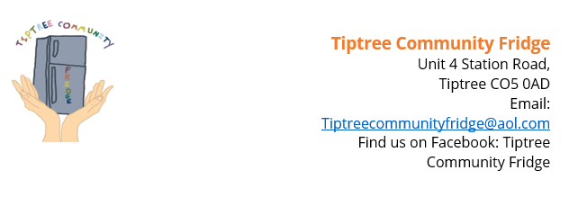

**Application for Over 65 Fleece Electric Blanket Tiptree Community Hub CIC**

|  |  |  |  |  |
| --- | --- | --- | --- | --- |
| Organisation Applying  ----------------------------------------------------------------------------------------  Address  -------------------------------------------------------------------------------------------------------------------------  -------------------------------------------------------------------------------------------------------------------------  Telephone Number Date / / 2023  -----------------------------------------------  Email Address  ----------------------------------------------- | | | | |
| **Criteria Must be over 65 plus must meet 2 further criteria. Please tick one from each column below.** | | | | |
| * Unable to afford to heat home * More than one resident in cold premises * Long term health condition * Mental health condition * Other (please state | | * Food Bank direct referral * Independent Age referral * Tiptree Volunteer direct referral * Tiptree Medical Centre referral * Community 360 referral * Provide referral * Social Care Direct Referral * Other (please state) | | |
| Name of recipient if possible  Please use NHS number or other identifying number if a name is not possible e..g.DOB + postcode |  | | | |
| Location of recipient (Tiptree, Messing etc.) |  | | | |
| Authorised by Print Name |  | | | |
| Signed |  | | Date | / / 2023 |
| Date blanket collected and dispensed by TCH Print Name |  | | | |
| Signed |  | | Date | / / 2023 |