
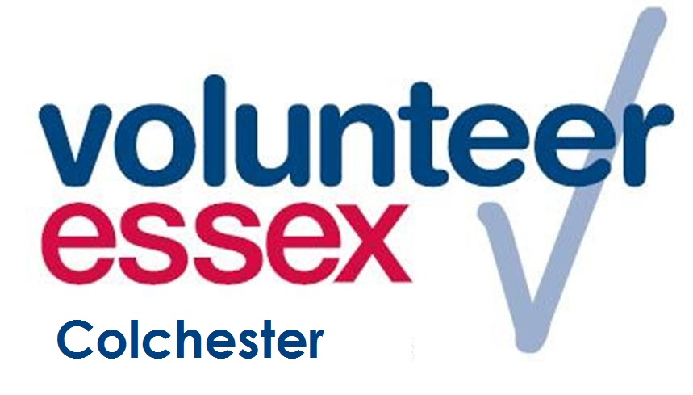

VOLUNTEERING OPPORTUNITY REGISTRATION

Name of Organisation:

 | Opportunity Details

The information you provide below will be used to match volunteers for this volunteering opportunity. It is important that the information you provide is as accurate as possible. This will help Volunteer Centres to attract suitable volunteers. Try to use language which emphasises the appeal of this volunteering opportunity, since this will help create interest. Volunteer Centres will make every effort to market your volunteering opportunity effectively.

Opportunity Title: (Please provide a short and appealing title for this opportunity, e.g. home visitor, telephone help-line volunteer, gardener, receptionist, retail assistant)
Description of Opportunity: Please provide us with a short and interesting description of what the volunteer will be expected to do. Please remember, the more lively the better! Please enclose a Role Description, if you have one.
Skills and Qualifications Required: Please provide us with details of any skills and/or qualifications that the volunteer should possess
 | Interests and Activities

Interests
Please tick any of the following that apply to the opportunity (maximum 3)

Arts, Heritage & Entertainment |  | Employment, Education & Training |  | Mental Health
Black & Minority Ethnic Communities |  | Environment |  | Older People
Children |  | Families & Parenting |  | Religion
Civic responsibility and communities |  | Fitness & Sport |  | Substance misuse & Addiction
Crime, Victims & Offenders |  | Health & Social Care |  | Wildlife & Animals
Disability |  | Homeless & Housing |  | Women’s issues
Emergency response |  | Lesbian, Gay, Bisexual & Transsexual |  | Young People

Activities
Please tick any of the following that apply to the opportunity: (maximum 3)

Administration and Office |  | Fundraising and Finance |  | Retail
Advice and information |  | Gardening |  | Sports volunteering
Business Skills |  | General helping |  | Supporting charities
Computers, IT and the web |  | Legal work |  | Supporting people & befriending
Cooking and Catering |  | Local events |  | Teaching and Training
Creativity |  | Marketing and media |  | Trusteeship and Committee work
Driving |  | One off volunteering
First Aid |  | Practical Skills

 | Location

Where will the volunteering take place?

Region or area  (please specify below) |  | Postcode

Basildon, Billericay & Wickford
 | Colchester |  | Southend
Braintree |  | Epping forest |  | Tendring
Brentwood |  | Harlow |  | Thurrock
Castle Point |  | Maldon District |  | Uttlesford
Chelmsford |  | Rayleigh & Rochford |  | Countywide

Will this opportunity consider people
In recovery |  | With Learning Disabilities |  | With no fixed abode
With Physical Disabilities |  | Personality disorders |  | With Mental Health Issues
With spent criminal convictions |  | Special Needs |  | Needs a support worker

 | Who should we contact about this opportunity?

Referral Name: (person with whom the volunteer would make contact)
Telephone
Email

I am happy for the above contact details to be passed on to prospective volunteers
Yes No

 | When will volunteers be needed?
 

Start Date:____________________ End Date:

 | Mon | Tue | Wed | Thur | Fri | Sat | Sun |  | Weekly
AM |  |  |  |  |  |  |  |  | Fortnightly
PM |  |  |  |  |  |  |  |  | Monthly
EVE |  |  |  |  |  |  |  |  | Occasionally
Flexible |  |  |  |  |  |  |  |  | One-off

Please tell us what time commitment you expect from volunteers, and if there are specific times when volunteers are required (e.g. lunch-club volunteers may be needed between 11am and 2pm)

 | Application process

Application form
Informal discussion
Interview
References
Disclosure and Barring Check (DBS)
(It is your responsibility to determine whether a DBS check is necessary and, if so, to ensure it is carried out. It is beneficial for Volunteer Centres to be able to inform prospective volunteers that start times may be delayed until the results of the DBS are known.)

Additional information

 | Yes | No | Any details
Suitable for under 18s |  |  | (i.e. 16+, 17+)
Training provided
Volunteer policy
Volunteers covered by insurance
Expenses reimbursed
Equal opportunities policy
Written role description
Disability Access
Volunteer induction
Health and Safety Policy
Ongoing support

I confirm that the above details are correct, and that I wish for the Volunteer Centres to promote this opportunity on behalf of my organisation. I understand that, whilst the Volunteer Centres accept responsibility to act reasonably and carefully when referring volunteers to an organisation, they act as referral organisations only. It is the role of this organisation to be responsible for the selection, screening and vetting of volunteers (taking up references, DBS checks etc). I will inform Volunteer Centres as soon as possible if this opportunity ceases to be available, or if any details change.

Name:
Organisation:
Date:

Please return this form to you local Volunteer Centre details can be found on www.volunteeressex.org/about

