Jo Blogs in May “WALK THIS MAY”
“I love walking because it clears your mind, enriches the soul, takes away stress, and opens up your eyes to a whole new world."
-Claudette Dudley.

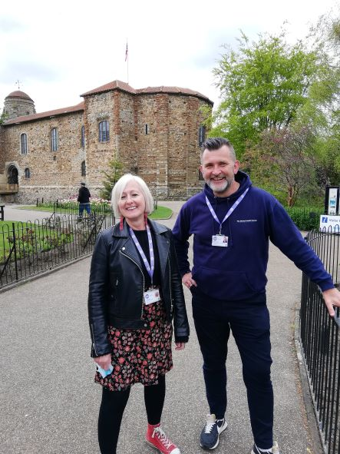

May is National Walking Month and it seems only fit to write a new Jo Blogs!
The weather is getting brighter, days longer and people are feeling more motivated to get out in nature again.
There are so many activities going on in our communities particularly with the Jubilee bank holiday weekend approaching fast too. Why not look in your local area and see what you can find that you may enjoy.
Its not just about walking but more about meeting and connecting with likeminded people and enriching your life and that of others.
Active Essex have a great toolkit for finding out what activities are going on where you live or further afield.
Take a look at “Find Your Active”. https://www.activeessex.org/find-your-active
It is really easy to use and has a great variety of activities for everyone at all levels of fitness and ability.
You could also check out your local leisure centre and try out something new. There are sometimes taster sessions and a variety of membership options to suit your budget and personal circumstances.
Sometimes we all struggle to find that motivation to try new things, but you never know until you try!
At C360 we have many walks in both Colchester and Braintree so just call to find out more or drop us an email.
information@community360.org.uk
T 01206 505250

For National Walking Month, C360 invite you to attend a walk and picnic in both Colchester and Braintree on 30th May.
The Colchester event is in Castle park at 5pm.
The Braintree event is in Braintree and Bocking public gardens from 12.30-2.00 pm.
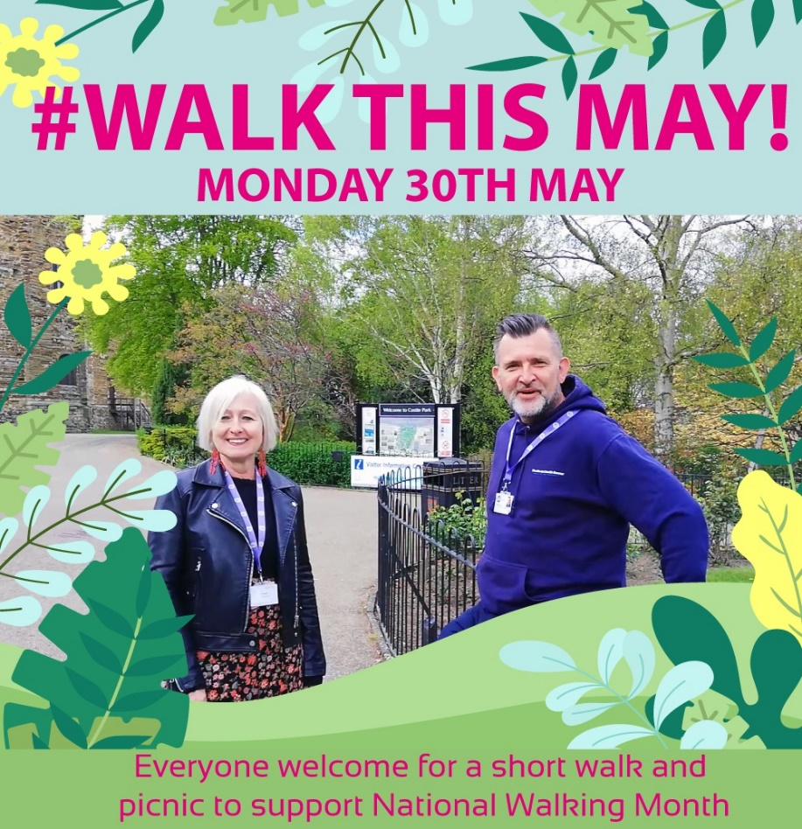

Staying motivated - Make it a habit
The easiest way to walk more is to make walking a habit.

Think of ways to include walking in your daily routine.

Examples include:
- walking part of your journey to work
- walking to the shops
- using the stairs instead of the lift
- leaving the car behind for short journeys
- walking the kids to school
- doing a regular walk with a friend
- going for a stroll with family or friends after dinner

“SPRING INTO MAY”, put a spring in your step and “WALK THIS MAY!”

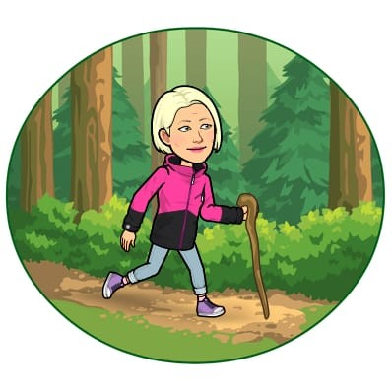

Jo Bryant Engagement Officer C360 May 2022

